HYCU Disaster Recovery Scenario for Azure cloud
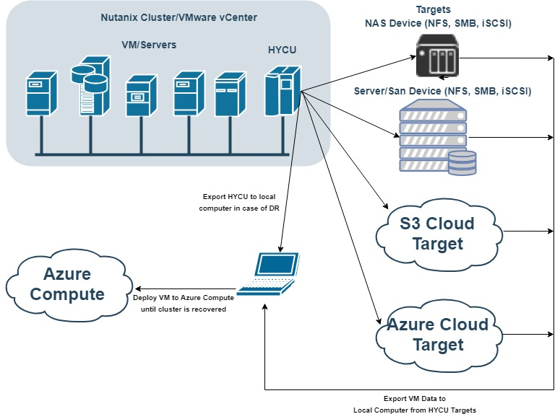

Prerequisites:
- Working Windows Physical Machine
- VMware Workstation player available for download on https://www.vmware.com/products/workstation-player/workstation-player-evaluation.html
- Installed and configured QEMU package for converting disk image files, Download QEMU From https://www.qemu.org/
- Backup of the HYCU backup controller (exported disk image files)
NOTE: use CTRL+ left mouse click on video links to open video
IMPORTANT: Watch for uppercase and lowercase letters in command

Contents
PREREQUISITE STEP 1 - Install QEMU tool 4
PREREQUISITE STEP 2 - Retrieve HYCU VM disk image files from backup target 6
STEP 1 – Recreate HYCU VM from its backup, using VMware Player 9
STEP 2 - Use HYCU to recover production virtual machines disk image files 16
STEP 3 - Install Azure PowerShell module and convert restored disk image(s) to vhd format 18
STEP 4 - Configure Azure for deployment 19
STEP 5 - Upload image to Azure and convert it to Azure Rm image 23
STEP 6 - Deploy the image into Azure and run the VM 25

PREREQUISITE STEP 1 - Install QEMU tool
  - video file
- Get QEMU from https://www.qemu.org/
- Install QEMU to local computer
- Add QEMU Install folder to Path Environment Variable
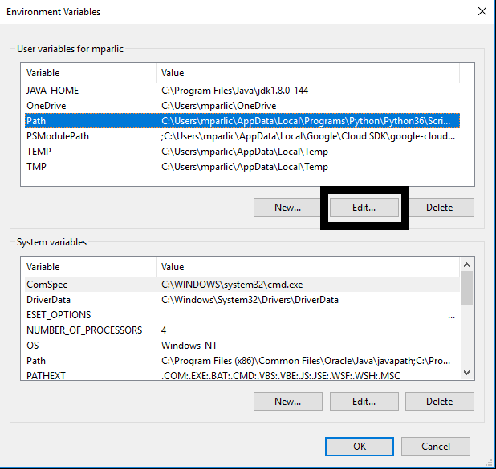
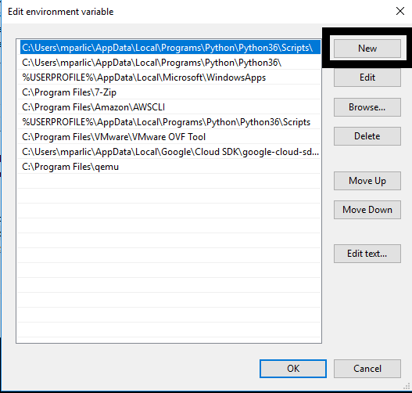
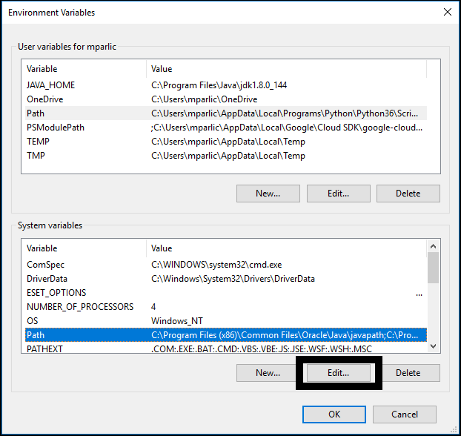
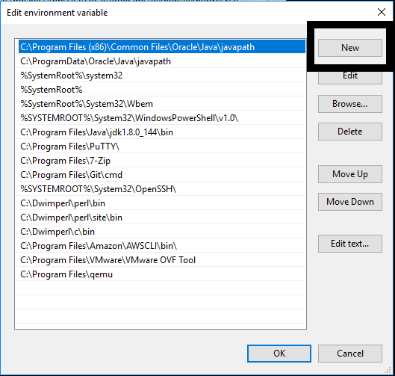

PREREQUISITE STEP 2 - Retrieve HYCU VM disk image files from backup target
  - video file
- Navigate to the target where backup of your HYCU backup controller is kept
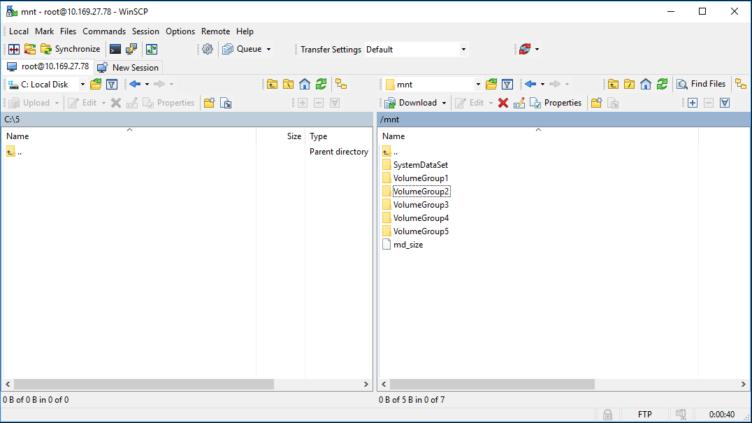
- Navigate to bkpctrl directory
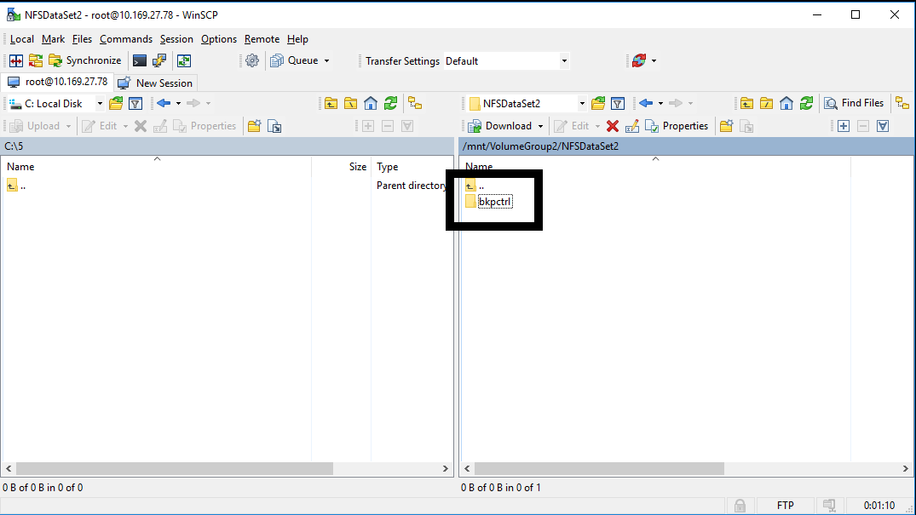
- Navigate to the HYCU uuid directory
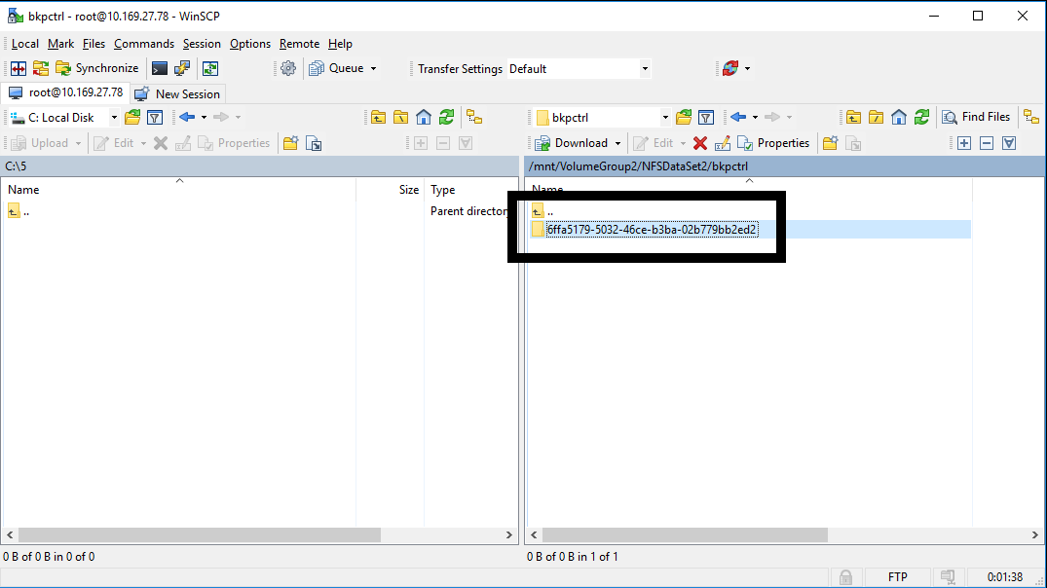

- Navigate to the directory internal_backup_<source UUID>
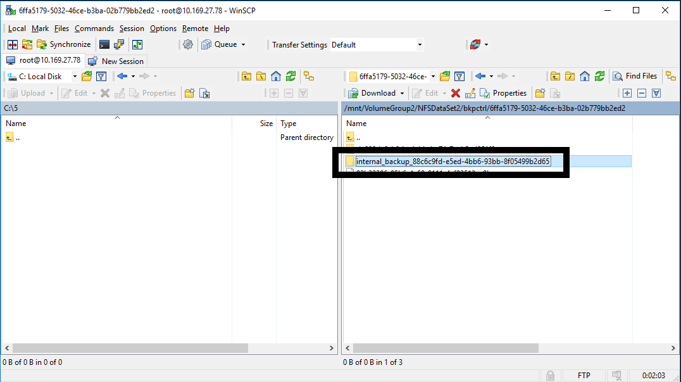
- Copy only the AHV raw disk image files (no extension) of HYCU backup controller disks to your local computer
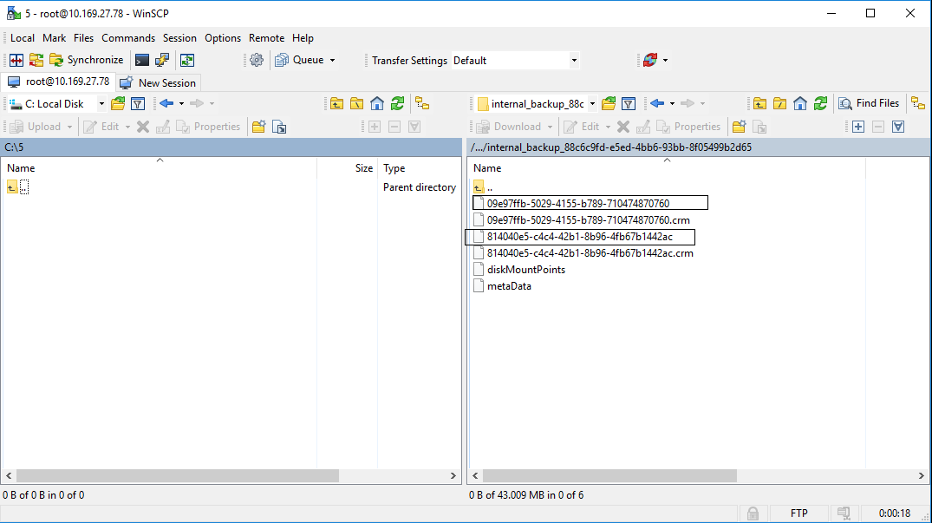
- Convert raw AHV disk image files to VMDK using QEMU tool
  - Smaller file (by default 10GB) is the HYCU system boot disk, the other one is HYCU data disk
  - Use the following commands
qemu-img convert -f raw -O vmdk <system disk image file> boot.vmdk
qemu-img convert -f raw -O vmdk <data disk image file> data.vmdk

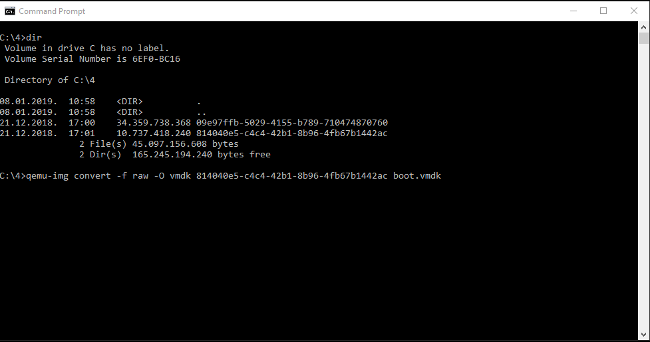
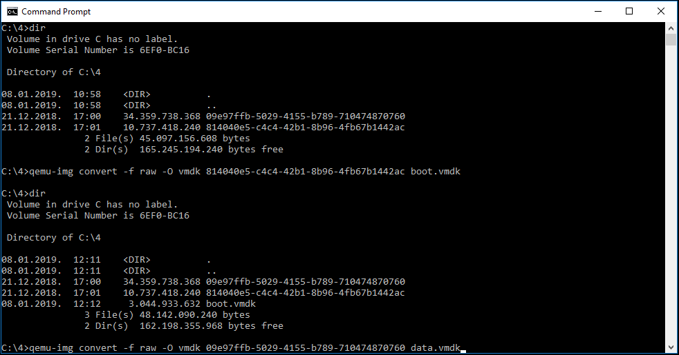

STEP 1 – Recreate HYCU VM from its backup, using VMware Player
  - video file
- Select Create New Virtual Machine
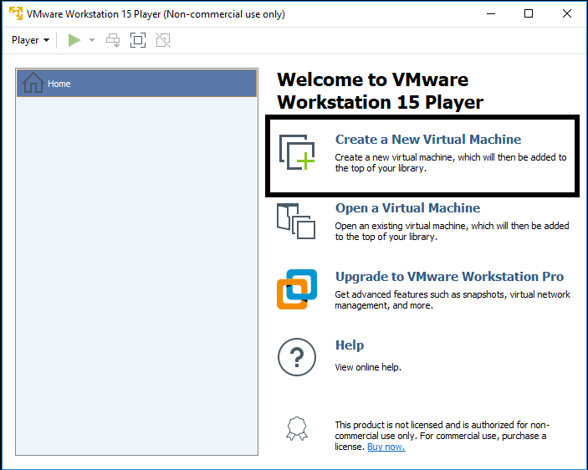
- On the next screen select “I will install operating system later”
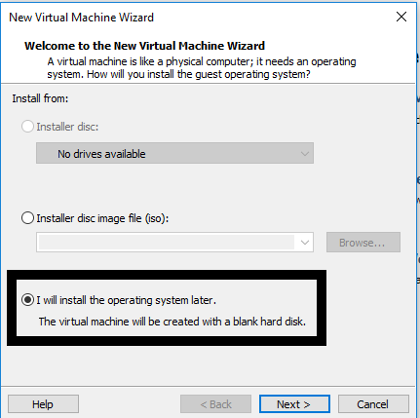
- On the next screen select Linux on top and Version CentOS 7 64-bit
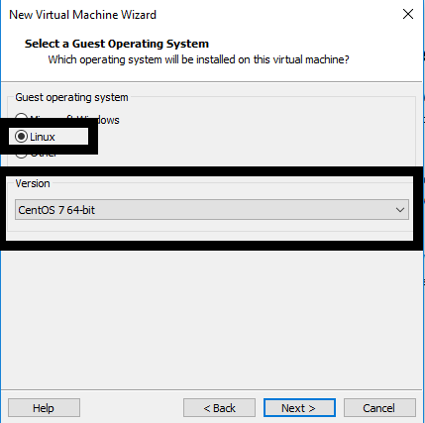

- Enter the VM name and select location on local computer where VM will be stored
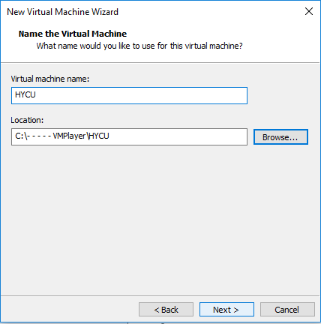
- Enter the size of VM boot disk (by default this is 10 GB) and select “Store Virtual disk as a single file”
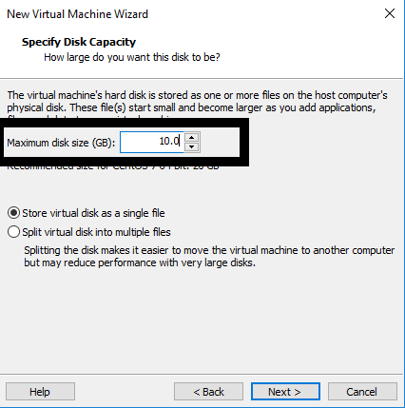
- Review VM details and click on Finish
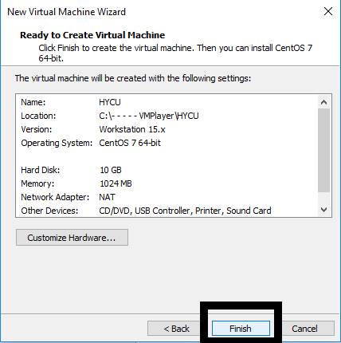

- Copy HYCU boot and data converted vmdk disk image files to the folder where your new VM was created
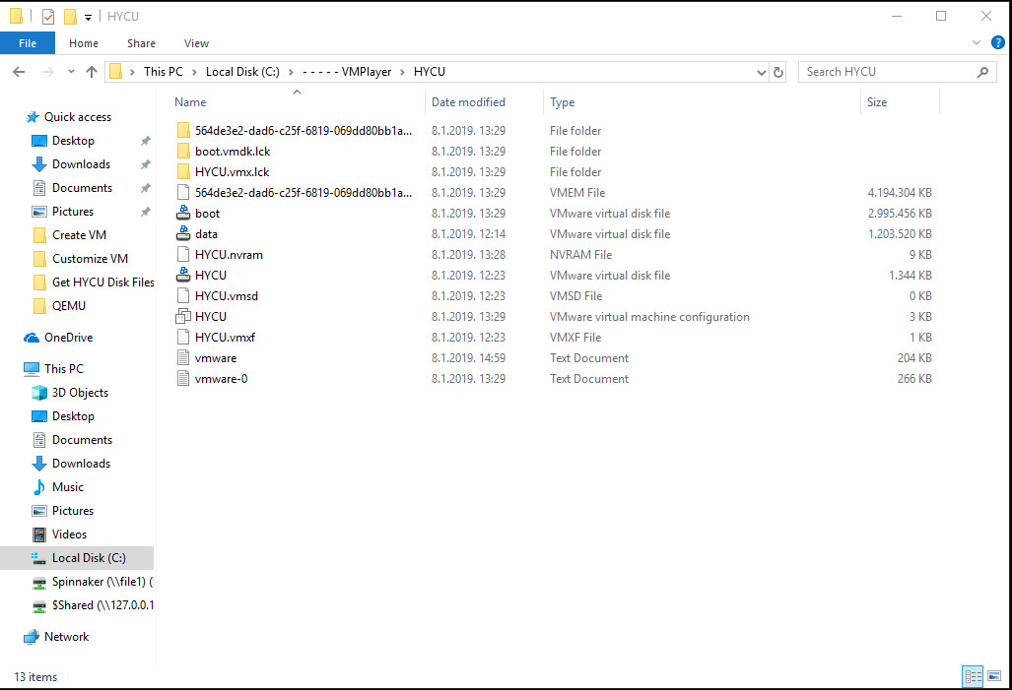
- Edit the .vmx file with a text editor. .vmx file is located in the folder where you created the new VM (change line scsi0:0.fileName = "HYCU.vmdk" to scsi0:0.fileName = "boot.vmdk")
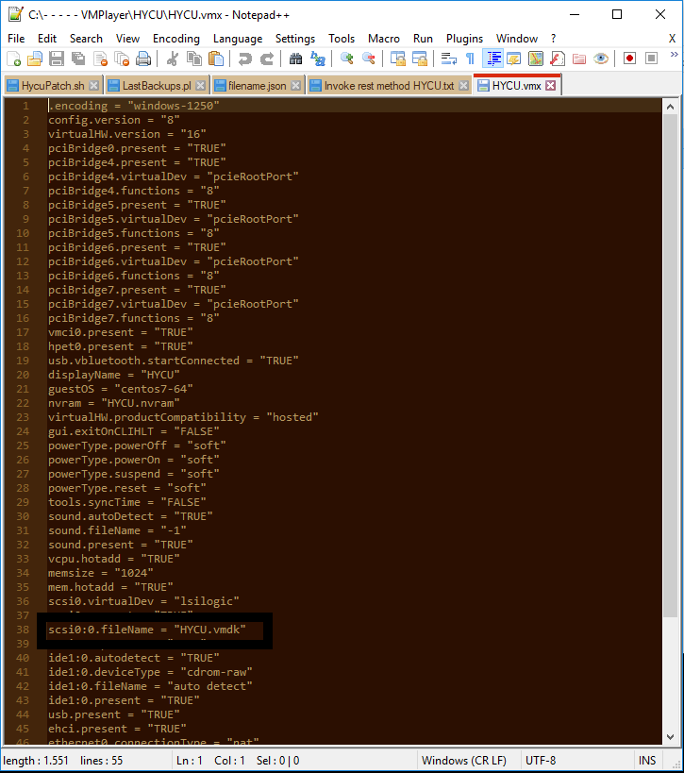
- Save the File

- Open VM player, select the VM and Select "Edit virtual machine settings"
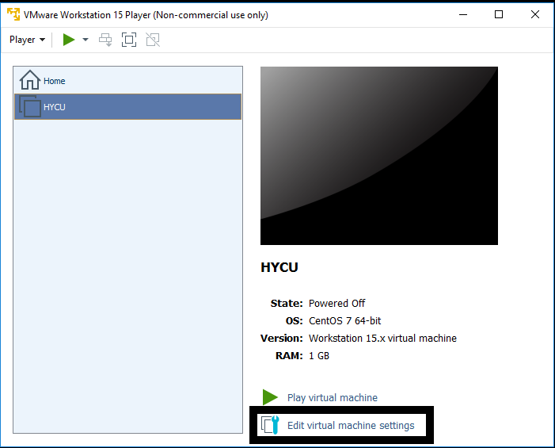
- Edit memory settings to 4 GB
- Edit Processors to 2 cores
- Remove the CD drive
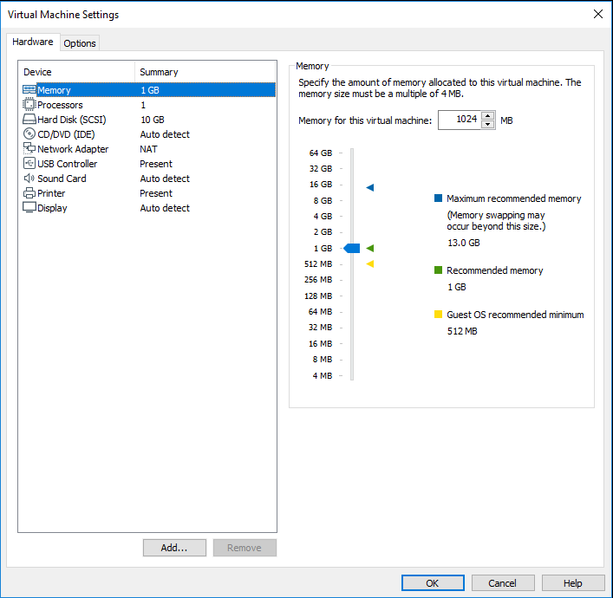

- Add another HDD, select SCSI hdd drive, "Use existing virtual disk" and browse for the HYCU data.vmdk disk image file. Click on finish and Keep existing format.
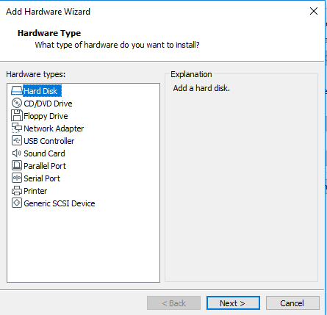
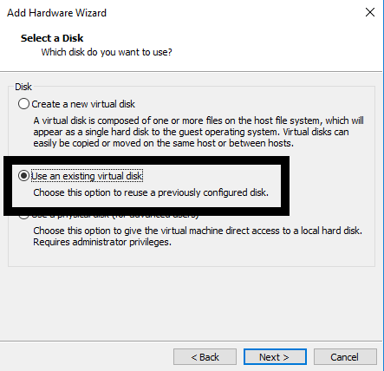
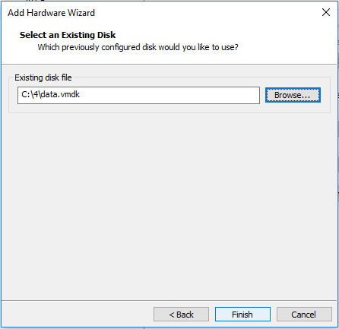
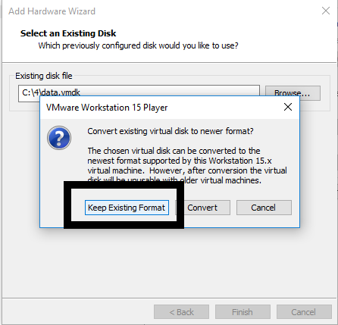

- On the network adapter select Nat
- Save the VM settings
- Run the VM
- When controller is up, login with your SSH credentials (by default this is hycu | hycu/4u). Use the command sudo nmtui to access network settings of the controller, you will be asked to enter the password one more time
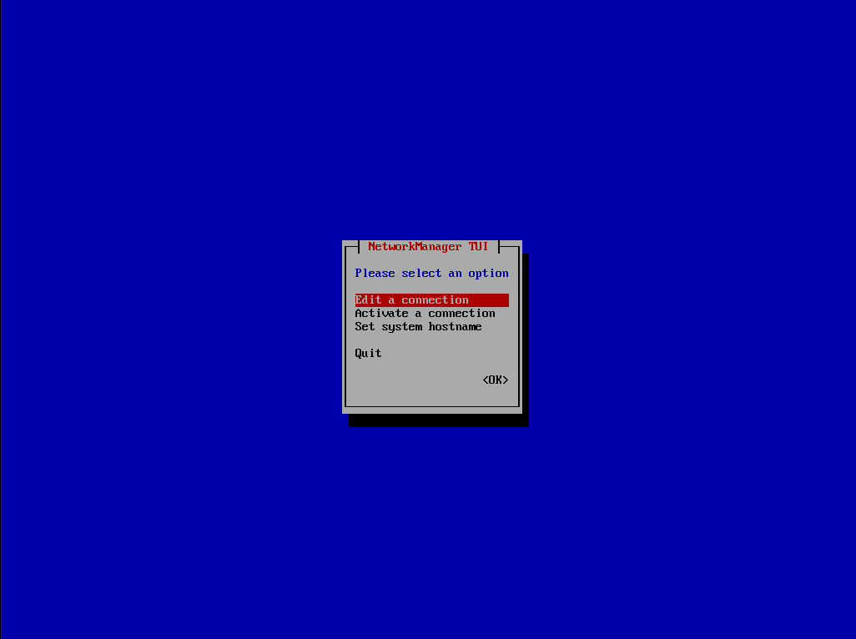
- Select Edit a connection
- Select Wired connection 1 and delete it
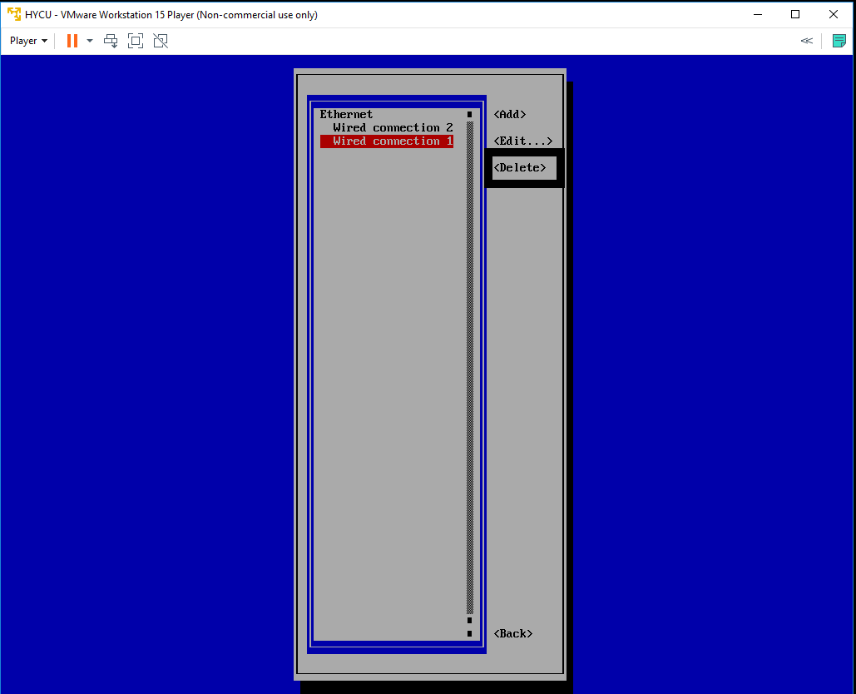
- Select Wired connection 2 and Edit it, change name to Wired connection 1
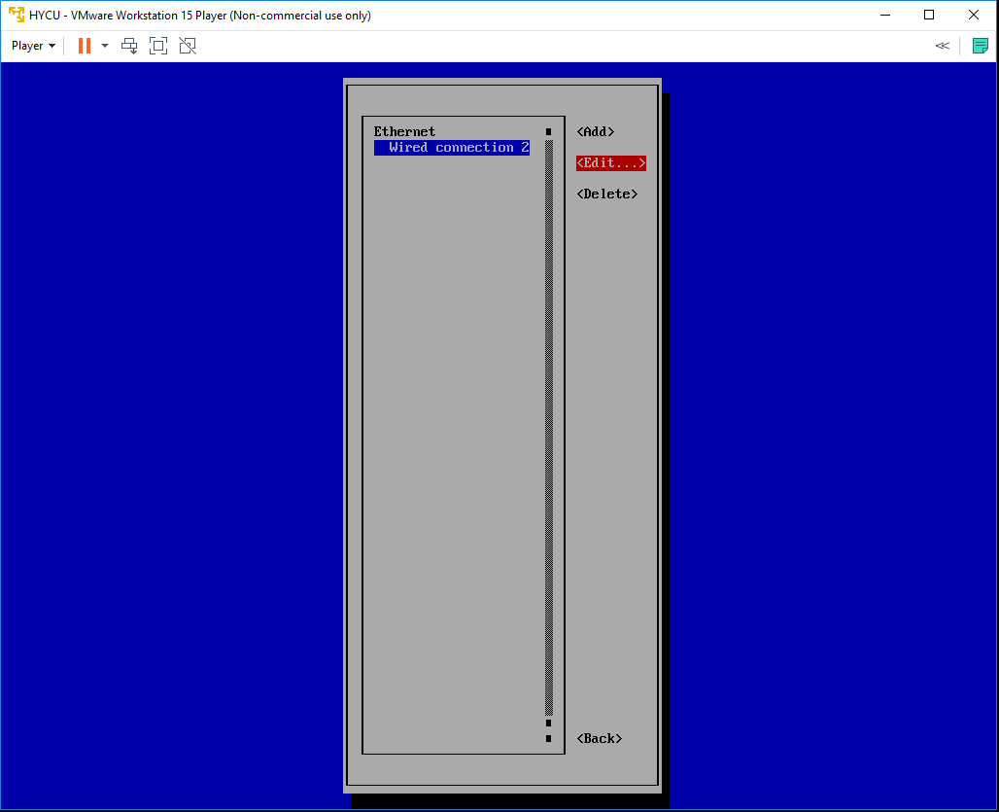
- Quit nmtui and reboot the HYCU controller VM by running sudo shutdown –r now
- SSH to the console with the same credentials and run ifconfig command to get controllers IP address
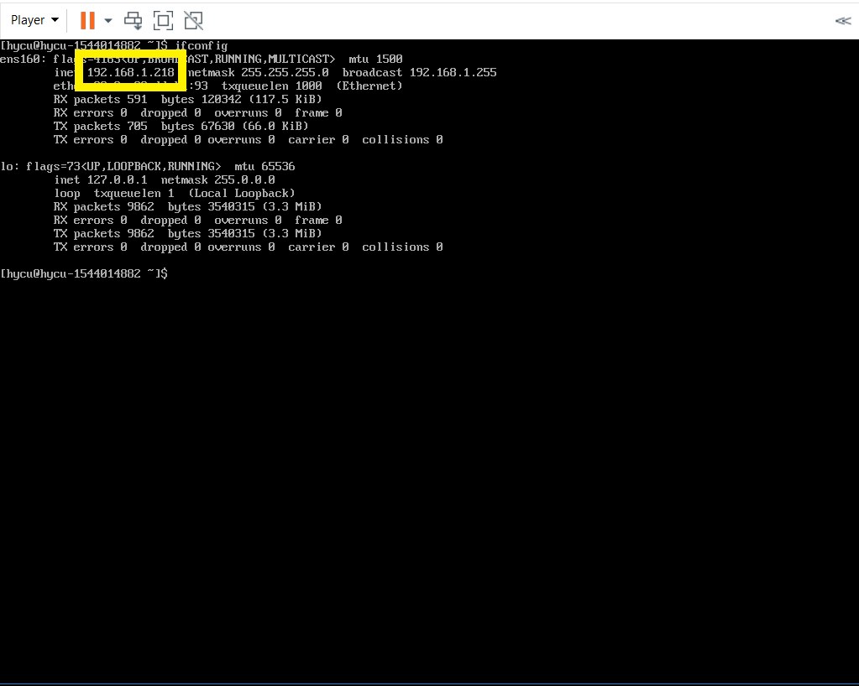
- Use that address to access HYCU GUI - https://IPaddress:8443

STEP 2 - Use HYCU to recover production virtual machines disk image files
  - video file
- Navigate to the HYCU Virtual Machines panel
- Protected VMs will be shown as PROTECTED_DELETED since source cluster is no longer available
- Select the desired VMs restore point and use “Restore VM or vDisks” option
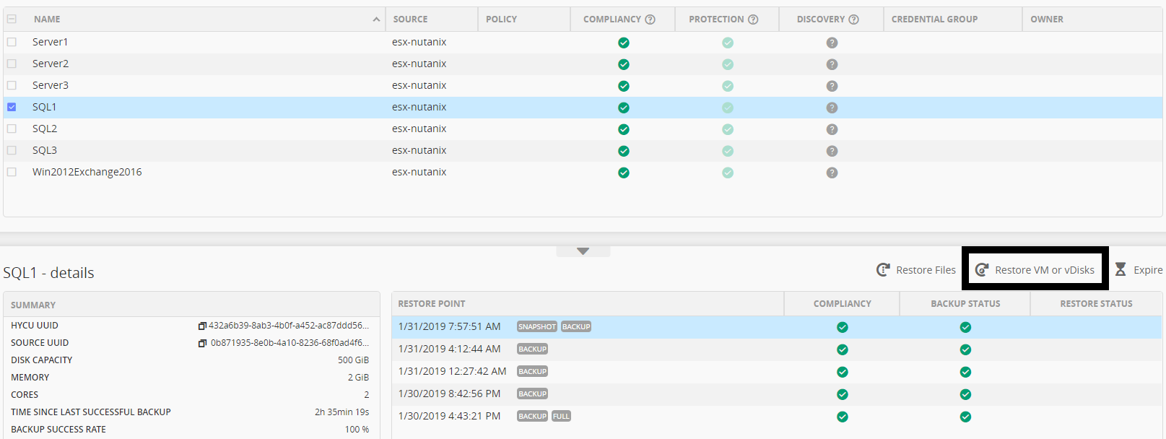
- New form will be shown. You can safely disregard the warning.
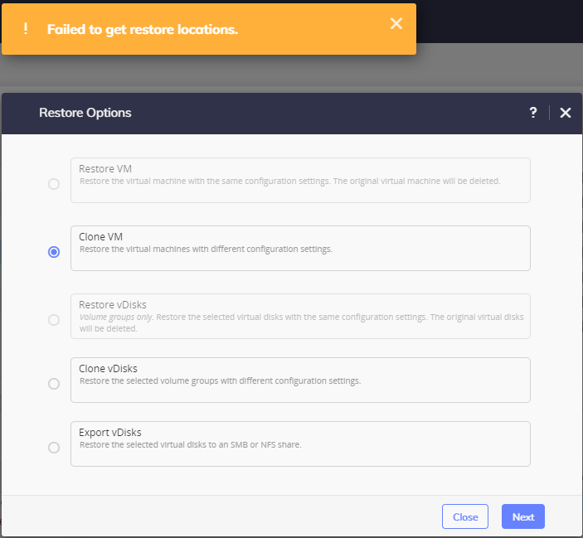
- Select “Export vDisks”
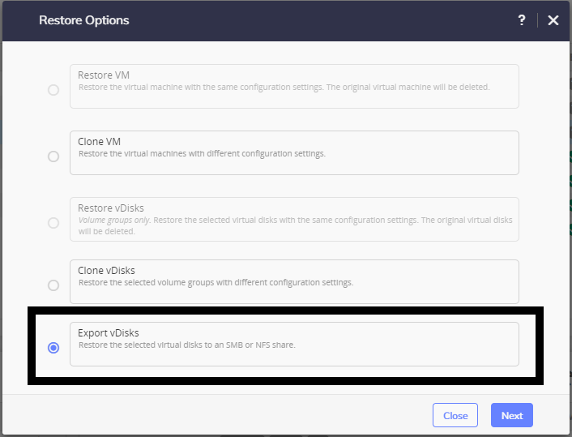

- Select vDisk(s) you want to export
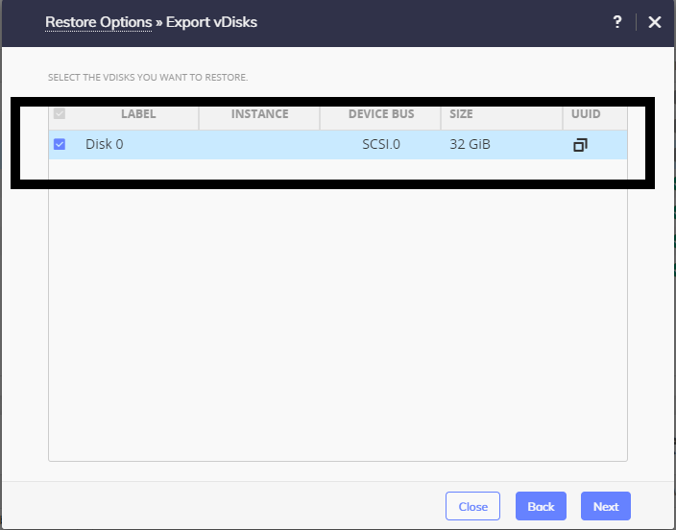
- Enter share Data
For SMB
- Domain, Username and Password are optional if exists
- Enter SMB server DNS name or IP address
- Enter Shared Folder name in format /<FolderName>
For NFS
- Enter NFS server DNS name or IP address
- Enter Shared Folder name in format /<FolderName>

- Restore Instance should be BACKUP
- Select Restore
- Once restore job is completed, you should have disk image files in specified folder. If you exported multiple disk you will have multiple raw (if exporting Nutanix ESX or AHV VM) or vmdk (if exporting non Nutanix VM) files in folder.
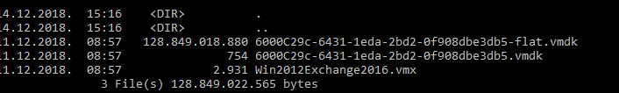

STEP 3 - Install Azure PowerShell module and convert restored disk image(s) to vhd format
  - video file
- Open PowerShell as administrator on your local machine and enter the following command Install-Module -name AzureRM -AllowClobber
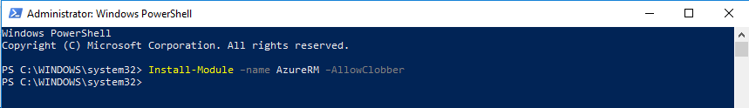
- Before uploading to Azure, images need to be converted to fixed size VHD disk images. Navigate to the folder where your exported image is located.
- Convert image using the following command qemu-img convert -f <type of source image raw/vmdk> -o subformat=fixed,force_size -O vpc <name of source image file> <name of image for upload>.vhd
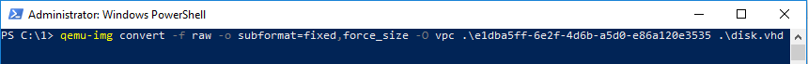

STEP 4 - Configure Azure for deployment
  - video file

- with your VHD disk image files prepared, next step is to login to your Azure compute account
NOTE: You will need administrator privileges on Azure
- Select Portal on top
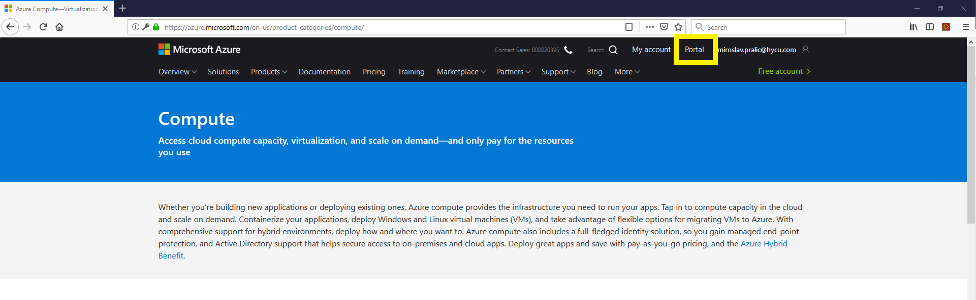
- On the portal you need to create a resource group. Navigate to the Resource groups in the left panel
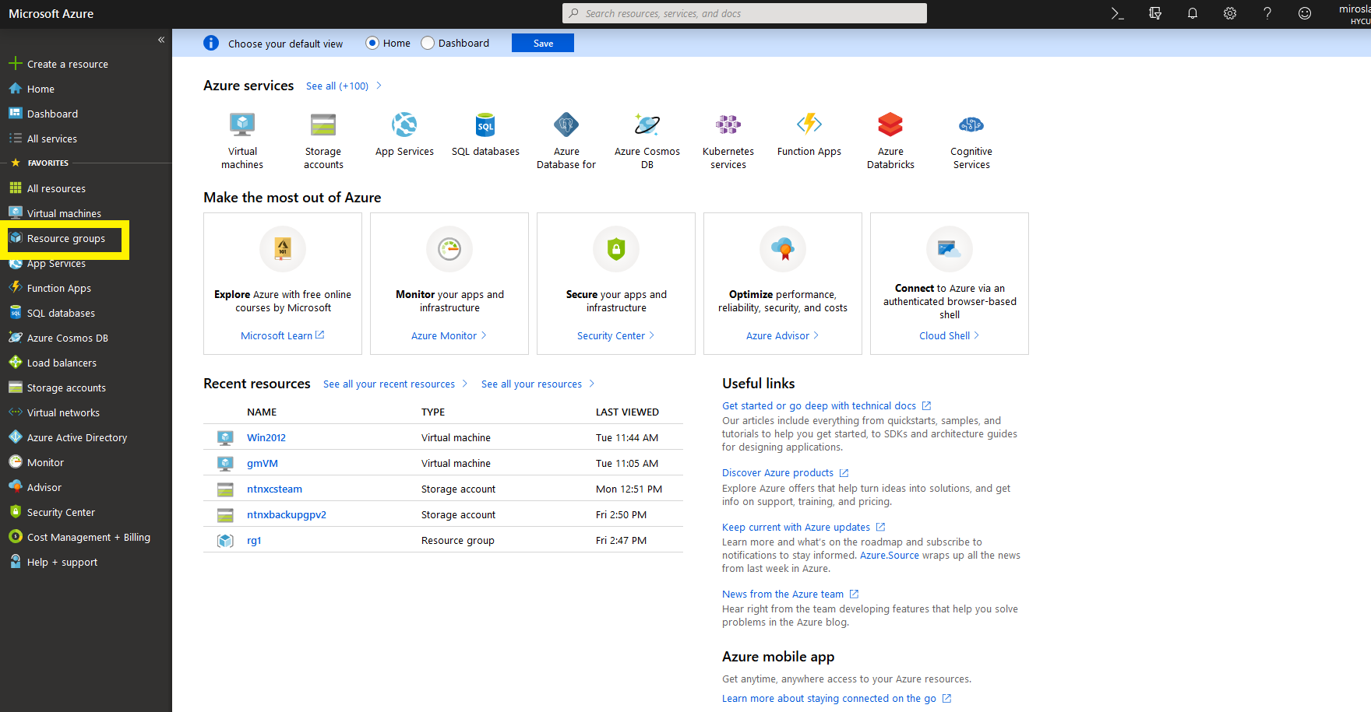
- Create a new Resource group by clicking on the Add button
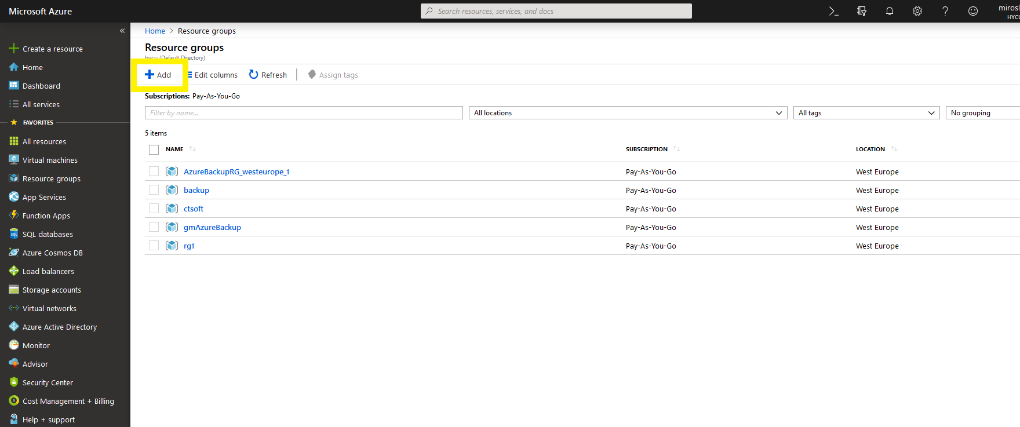

- Select your subscription model, enter the group name and select your region
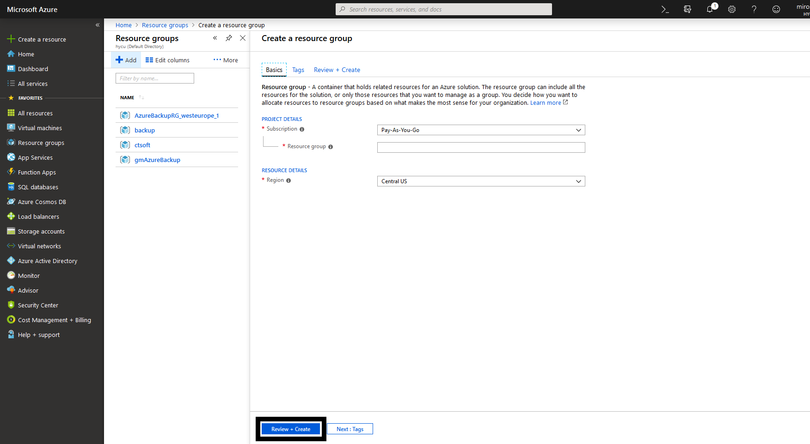
- Click on “Review + Create” button on the bottom, and once again to Create button
- Select Storage accounts in left panel
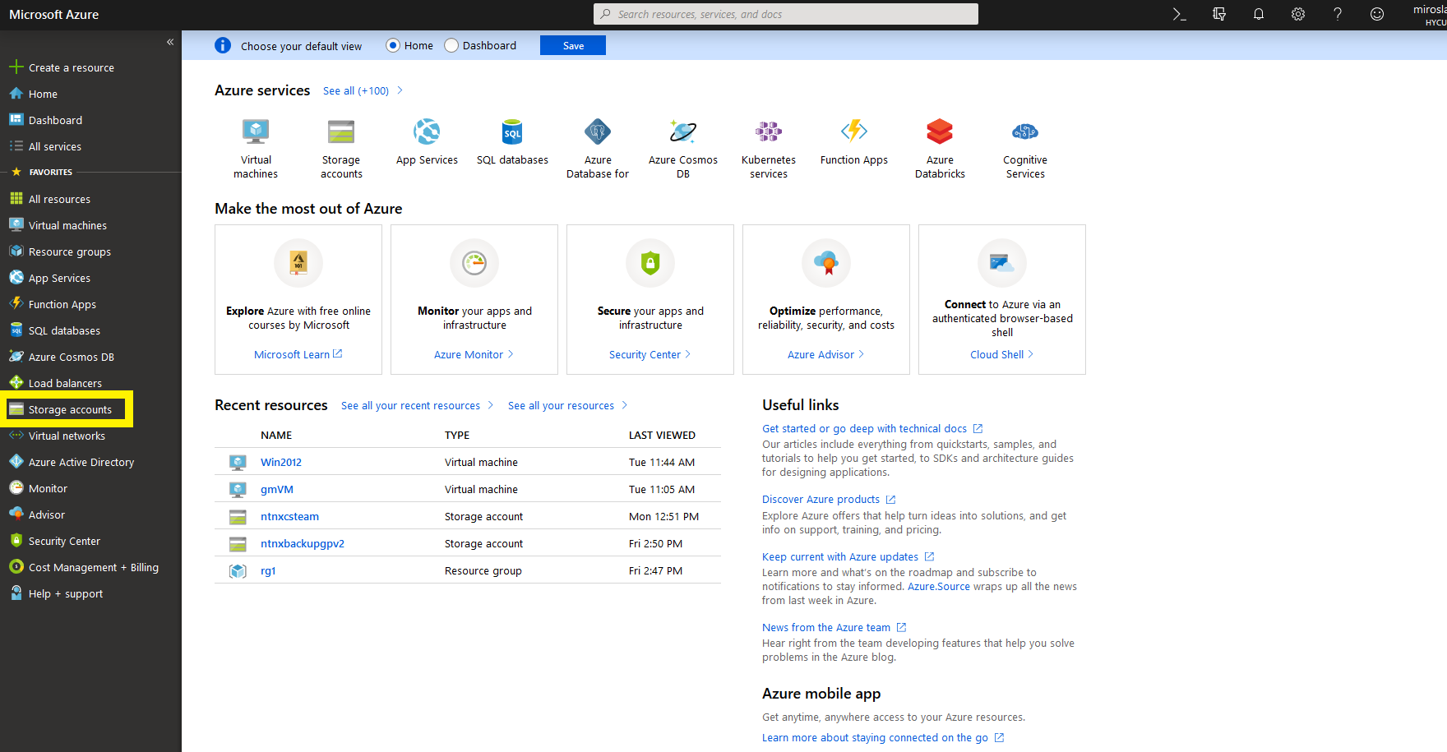
- Add new Storage account

- Select your subscription model, choose the Resource group that you just created, enter account name, select location, performance, for Account kind select StorageV2 and for access tier Hot.
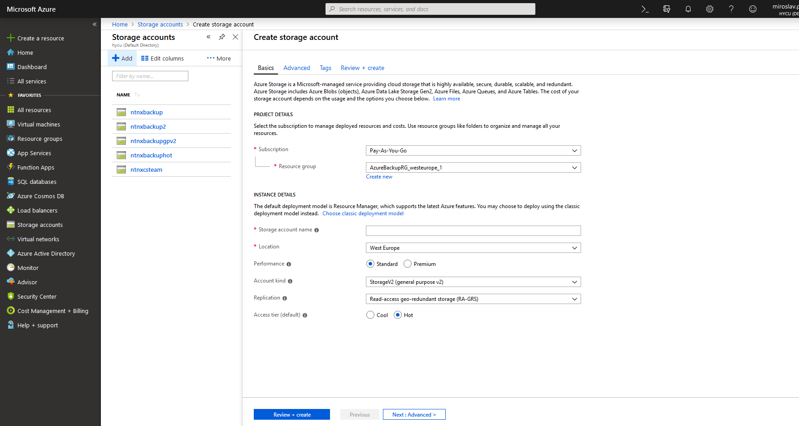
- Click on Review + Create and confirm Create
- Select the Storage account in the left panel again
- Click on the account you just created
- Select Blobs
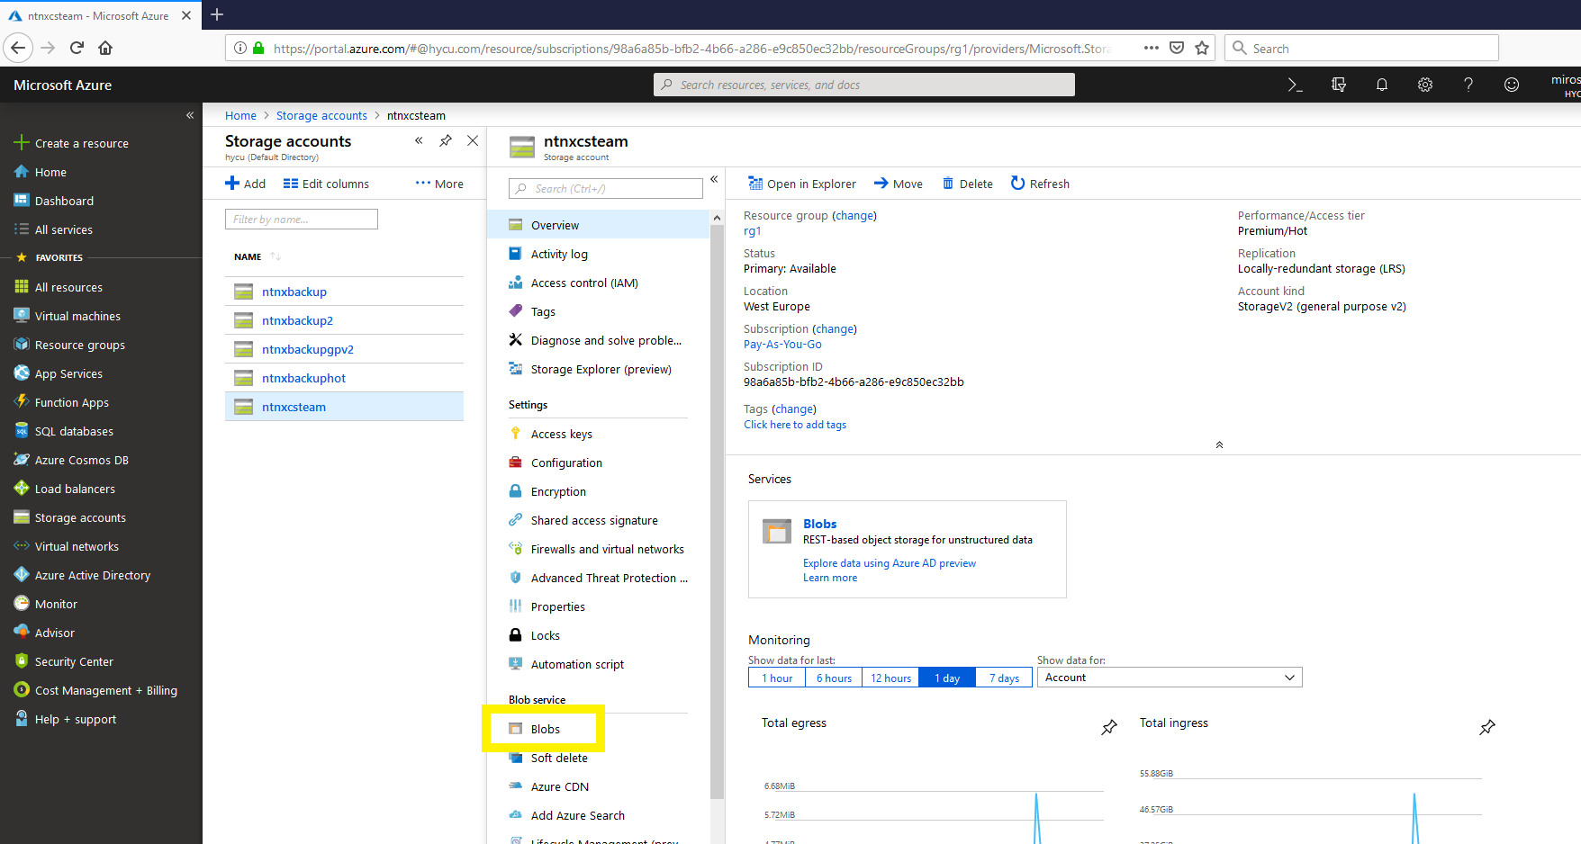
- Add new Container

- Select new Container that you just created, click on Properties in the left menu
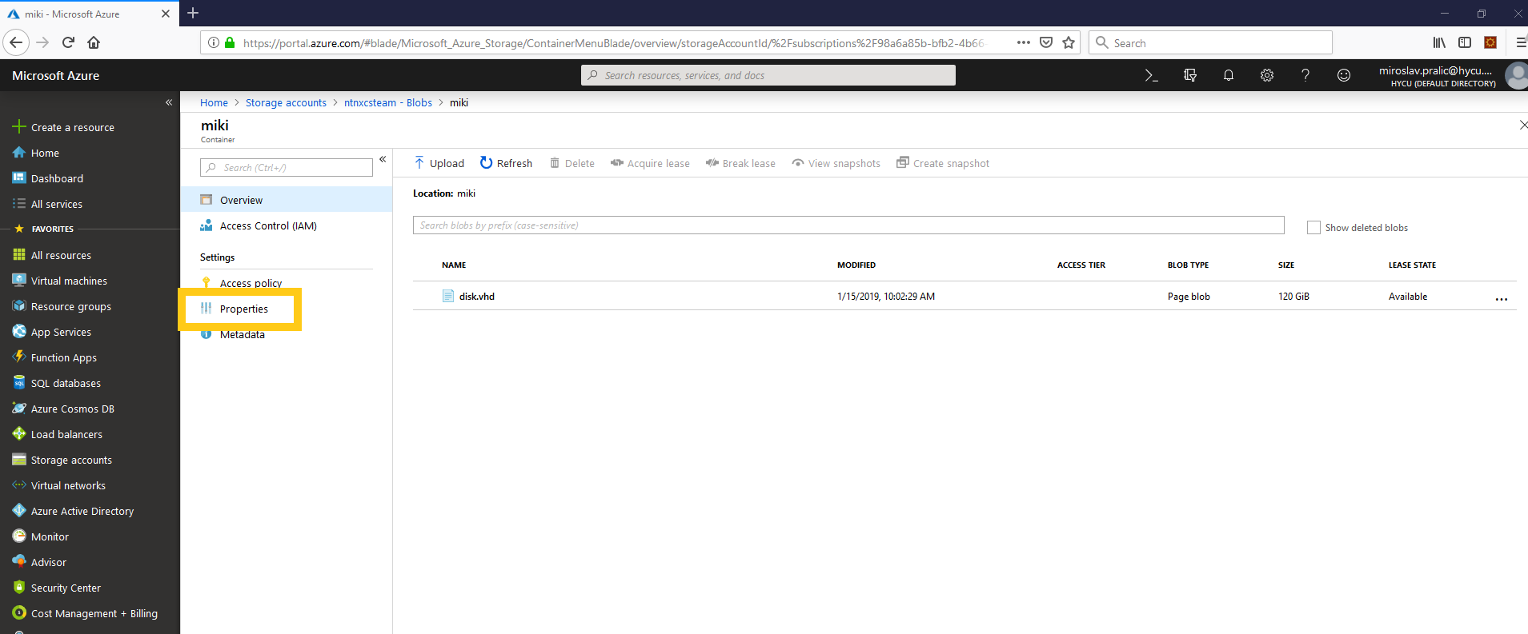
- Get value from URL field, it should be https://<storage account name>.blob.core.windows.net/<blob name>
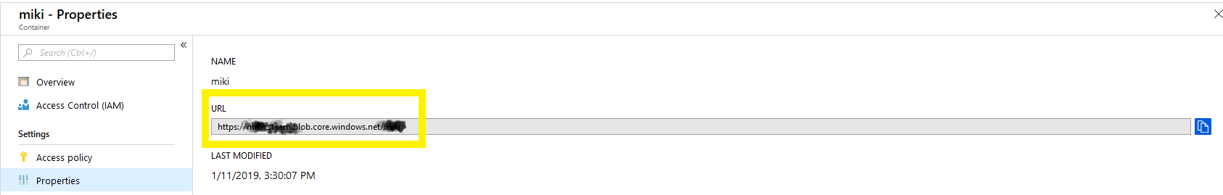

STEP 5 - Upload image to Azure and convert it to Azure Rm image
  - video file
- Run PowerShell as an administrator and go to the folder containing your converted .vhd disk image(s)
- Connect PowerShell with your account by using the following command Connect-AzureRmAccount
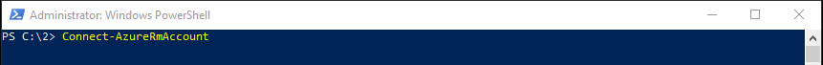
- In the new window enter Azure account user name, and later the password
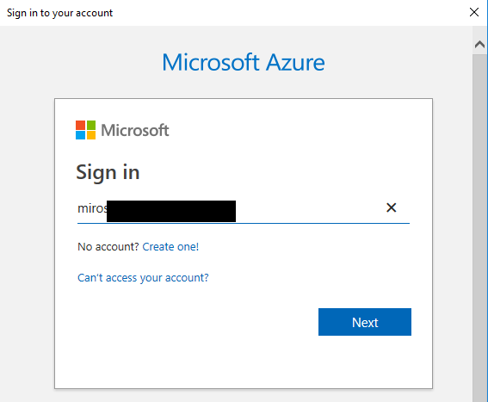
- On successful connect you will see the account details
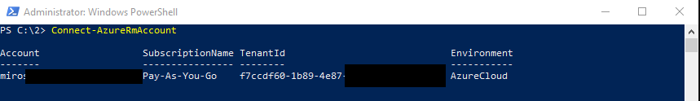
- Resource group and upload URL variables need to be created by entering triggering following commands from the PowerShell window
$rgname = "<Resource group name you created in step 4.5>"
$uploadURL = "<url from step 4.16>/<name of your vhd disk file>.vhd"
- Use the following command to upload VMs disk image file to Azure
Add-AzureRmVhd -ResourceGroupName $rgName -Destination $uploadURL -LocalFilePath "<absolute path> \<image name>.vhd"
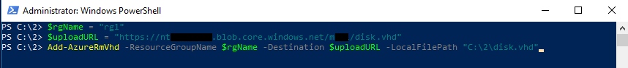
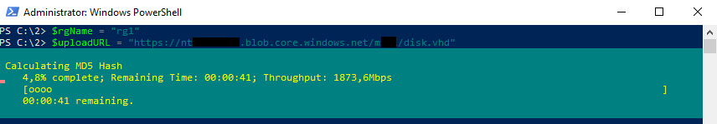
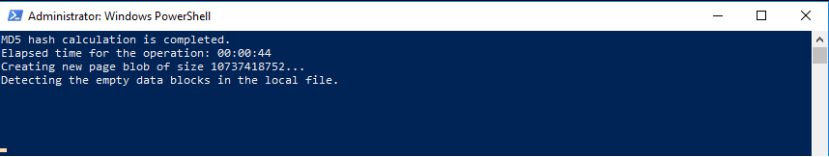
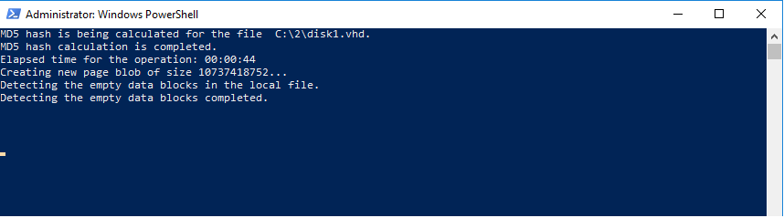
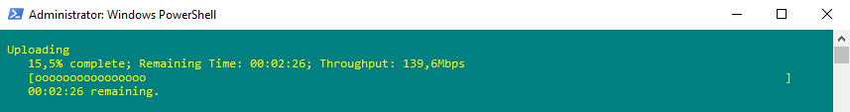
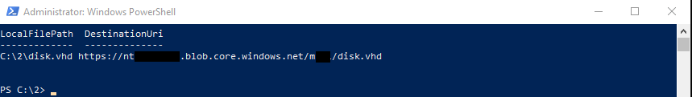

- New Variables need to be created, execute following commands
$location = "<your blob location configured in step 4.9>"
$imageName = "<new Azure image name>"
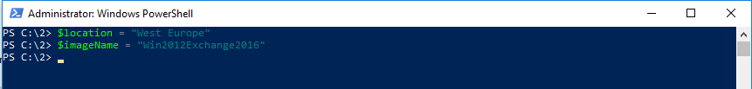
- To create the Azure image using your VM .vhd disk image file, use the following commands
$imageConfig = New-AzureRmImageConfig -Location $location
$imageConfig = Set-AzureRmImageOsDisk -Image $imageConfig -OsType <VM OS Type> -OsState Generalized -BlobUri $uploadURL -DiskSizeGB <size of uploaded disk> (equal or bigger then size of uploaded disk)
New-AzureRmImage -ImageName $imageName -ResourceGroupName $rgName -Image $imageConfig
Once completed successfully following message will be displayed
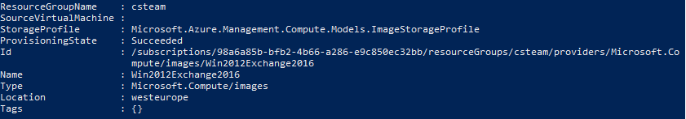

STEP 6 - Deploy the image into Azure and run the VM
  - video file
- Return to Azure portal and Select Virtual Networks in left panel
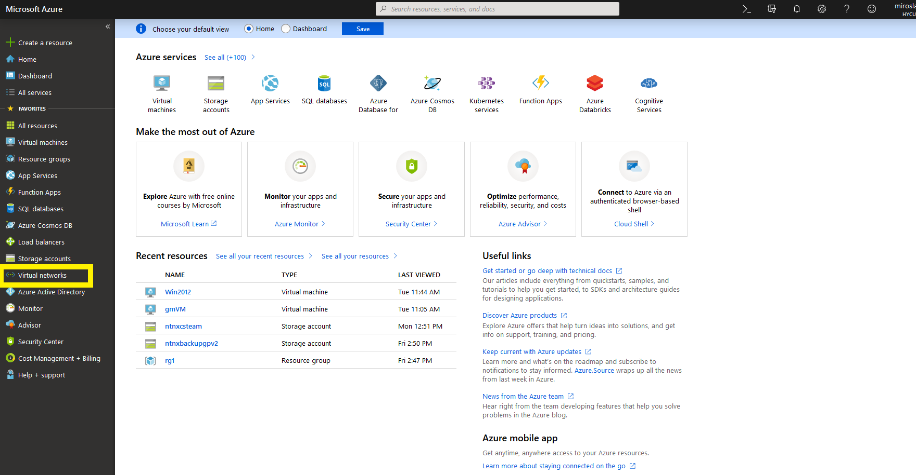
- Click on Add
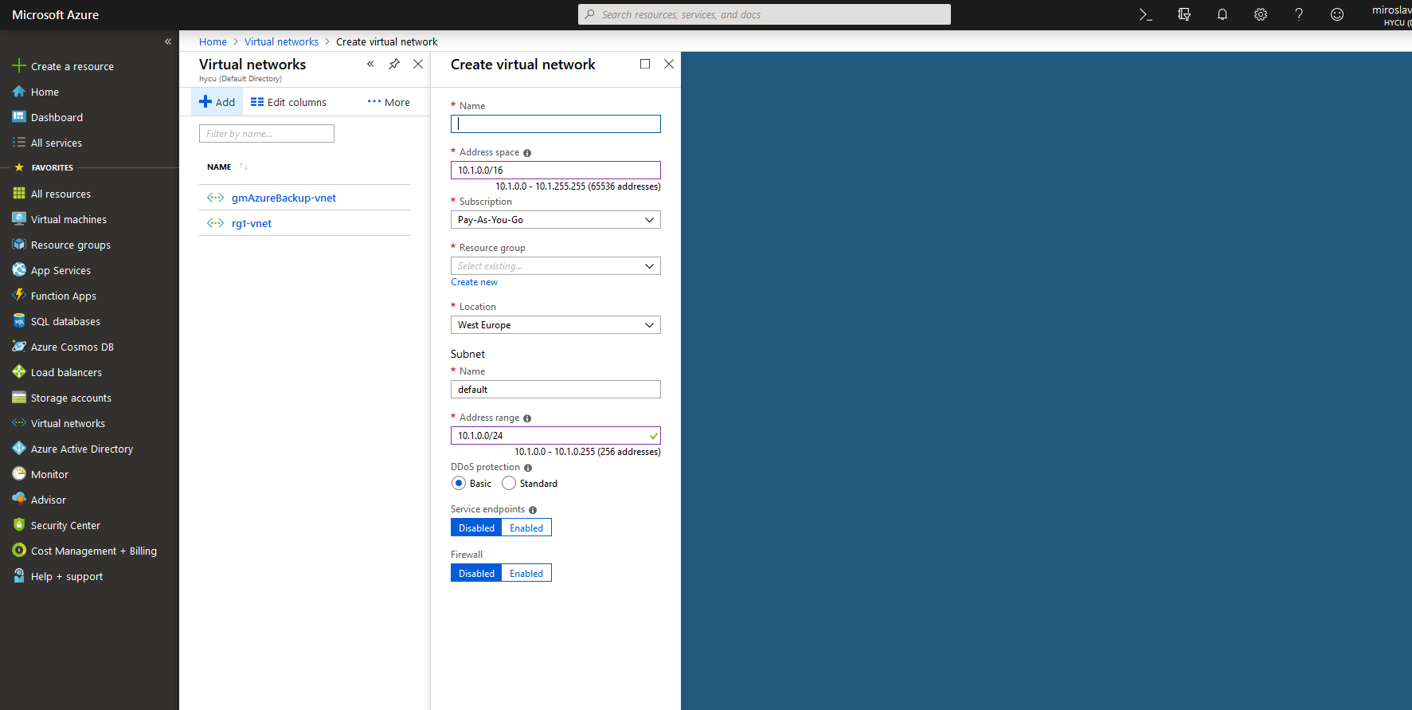
- Enter name, select Address space, select Subscription, choose Resource group that you created, select location, enter name for the subnet, select Address range and click on create
- Select the Virtual machines in the left panel
- Click on add and select Subscription, select resource group that you created, enter the VM name, select Region to match location that you selected before, select Availability options if needed

- Click on Browse all images
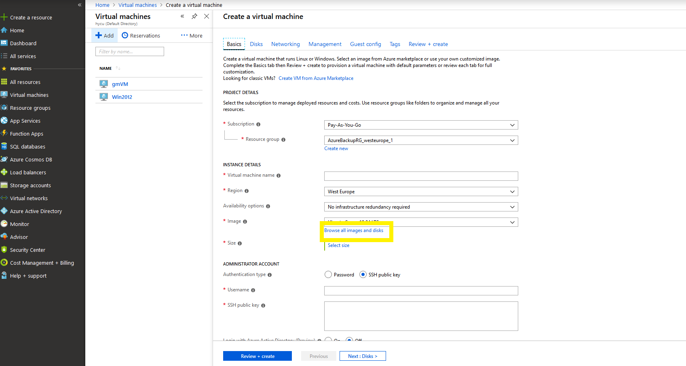
- Select My Items
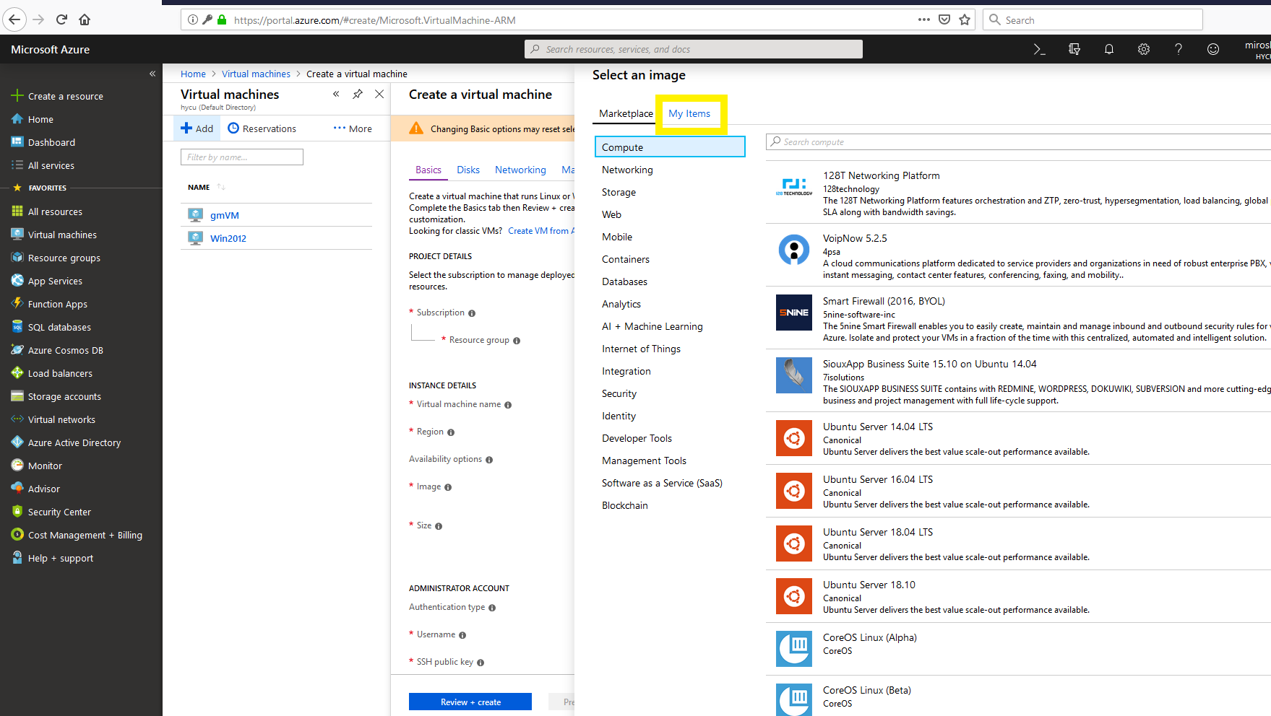

- Select the image you created in step 5
- Adjust the size of your VM, select authentication type to password and enter username and password
NOTE: username is limited by max 20 characters
Select public inbound ports, for windows VM use RDP port. Click on Review and Create
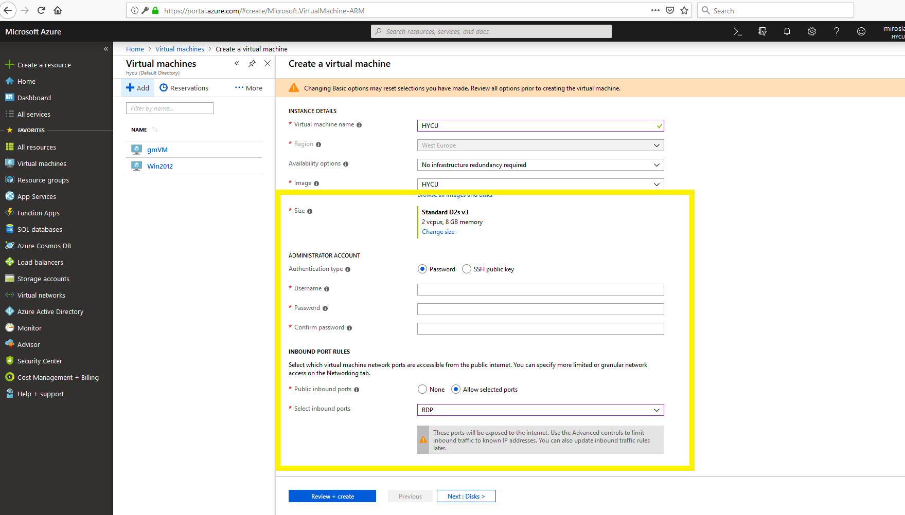
- If validation passed click on Create. Creation process will take some time. Once process is completed, navigate to the Virtual machines in the left panel, select the VM that you created, and press start to run it.
- To access the VM click on connect and choose RDP or SSH access to VM

